October Newsletter
Keswick Ridge School
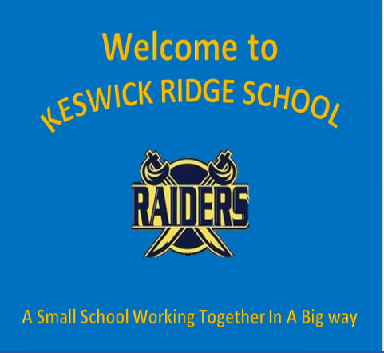

Upcoming Events

October 3rd – 9th
Fire Prevention Week
October 11th
Thanksgiving – No School
October 12th – 15th
Kindergarten Registration
October 18th – 22nd
Safe Schools Week
October 18th
School Picture Day

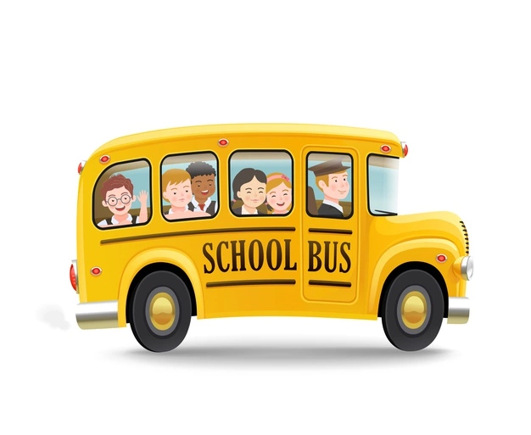
Bussing information can be found at:
https://asdwbp.nbed.nb.ca/
or by calling (506) 453-5454

166 McKeen Drive, Keswick Ridge, E6L 1N9
(506) 363-4703
Acting Principal: Chris Roach
Acting Vice-Principal: Melissa Chetwynd
Welcome Back!

Kindergarten Registration
Kindergarten registration for the 2022-2023 school year runs from Tuesday, October 12th to Friday, October 15th. Registration is primarily done online using the following link:
https://secure1.nbed.nb.ca/sites/ASD-W/kindergarten/Pages/default.aspx
If you are not able to access the online registration from, you can contact the school directly to book an appointment to register.
Covid and Mask Use
At this time, masks are mandatory for all staff and students both on the bus and inside the school. The only exception to this is when students are eating. Masks are not required on the playground. We ask that students arrive daily with two clean masks. Students with one Covid symptom may attend school. Students with two or more symptoms must remain home.
Lost And Found
There are quite a few items in our lost and found bin here at the school. Pictures of these items have been posted to our school Facebook page. Parents can contact their child’s teacher, or comment directly on the photos to claim an item. Any items not claimed by Tuesday, October 12th will be donated

Friends of KRS Pumpkin Fundraiser

School Cash Online
Fees can be paid online at:
https://anglophonewest.schoolcashonline.com

Tomorrow (Oct 6th) is the last day to order a pumpkin from our Annual Pumpkin Fundraiser. Cost is $5 per pumpkin, and orders must be placed online through School Cash Online. Pumpkins can be picked up at the school on Saturday, October 9th from 10 a.m. – 12 p.m.

Visitors
As a precaution, we are not allowing visitors to enter the building without an appointment. To make an appointment please contact your child’s teacher or the main office at (506) 363-4703
Communication
Don’t forget that we communicate regularly through both our Keswick Ridge School Facebook page as well as our website:
https://secure1.nbed.nb.ca/sites/ASD-W/KeswickRidge/Pages/default.aspx

